**Practical: 3**

**Que:1 Using HTTP and other required core modules, create HTTP server and display the following message to console and on the webpage for different URL entered by the user.**

(1) If user enter “/ ” then display “This is test”

(2) If the user enters ”/exam” then display the following table.

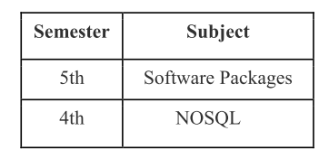

(3) If user enter “/exam/regular_exam” then display “Regular exam”

Note: You can use either switch case or else if statement.

const http=require("http")

const server = http.createServer((req,res)=>{

if(req.url==='/')

{

res.write("This is test")

}

else if(req.url==='/exam')

{

var out="<html> <body> <table

border='1px'><tr><th>Semester</th><th>Subject</th></tr><tr><td>5th

Sem</td><td>Software Packages</td></tr><tr><td>4th

Sem</td><td>NOSQL</td></tr></table></body></html>"

res.write(out);

}

else if(req.url==='/exam/regular_exam')

{

res.write("Regular exam");

}

res.end();

});

server.listen(6442,()=>{

console.log("Connected Sucessful");

});

**Output:**

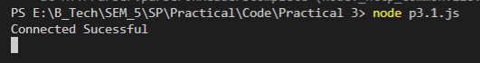

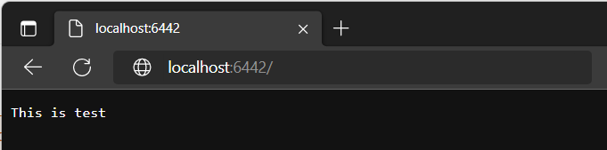

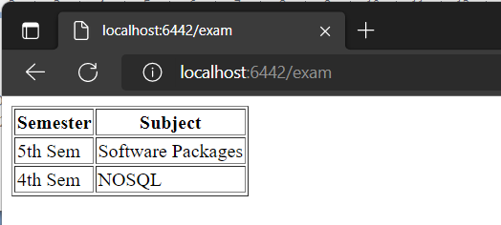

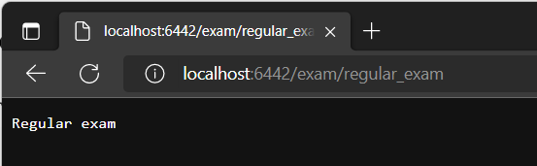

**Que:2 In a given query string of URL, give two parameters num1 and num2 and assign integers values to them and then find the greatest number among those two numbers.[URL: localhost:8080/?num1=49&num2=34].**

const url1 = require('url');

const http = require('http');

http.createServer(function(req,res){

    var data1=url1.parse(req.url,true);

    var num1 = parseInt(data1.query.num1);

    var num2 = parseInt(data1.query.num2);

    if(num1>num2)

    {

        res.end(num1+" is  greatest  number");

    }

    else if(num2 > num1)

    {

        res.end(num2+" is  greatest  number");

    }

    else

    {

        res.end(num1+" and "+num2+" are equal");

    }

}).listen(5214);

**Output:**

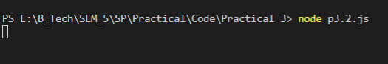

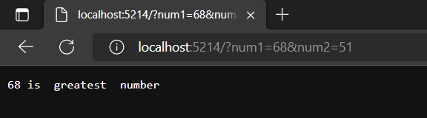

**Que:3 Create a local module which contains 4 functions for multiplication, addition, subtraction and division. Export it in another file main.js and display their result.**

**p3.3.js**

var add = function(num1, num2)

{

return num1+num2;

}

var sub = function(num1, num2)

{

return num1-num2;

}

var mul = function(num1, num2)

{

return num1*num2;

}

exports.add=add

exports.sub=sub

exports.mul=mul

**main.js**

var cal = require('./p3.3.js');

console.log("Addition is: "+cal.add(14,5));

console.log("Subtraction is: "+cal.sub(14,5));

console.log("Multiplication is: "+cal.mul(14,5));

**Output:**

